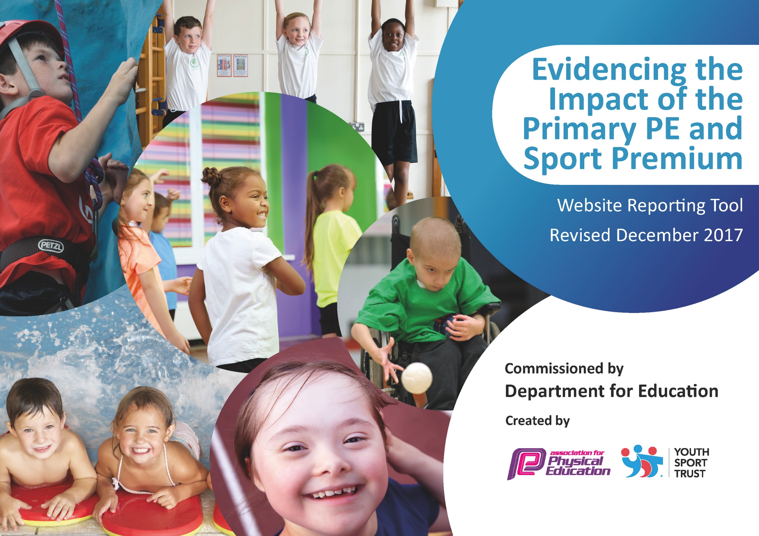

Schools must use the funding to make additional and sustainable improvements to the quality of PE and sport they offer. This means that you should use the Primary PE and Sport Premium to:

- develop or add to the PE and sport activities that your school already offers
- build capacity and capability within the school to ensure that improvements made now will benefit pupils joining the school in future years

Please visit gov.uk for the revised DfE guidance including the 5 key indicators across which schools should demonstrate an improvement. This document will help you to review your provision and to report your spend. DfE encourages schools to use this template as an effective way of meeting the reporting requirements of the Primary PE and Sport Premium.

We recommend you start by reflecting on the impact of current provision and reviewing the previous spend.
Under the Ofsted Schools Inspection Framework, inspectors will assess how effectively leaders use
the Primary PE and Sport Premium and measure its impact on outcomes for pupils, and how effectively governors hold them to account
for this.

Schools are required to publish details of how they spend this funding as well as on the impact it has on pupils’ PE
and sport participation and attainment.
We recommend regularly updating the table and
publishing it on your website as evidence
of your ongoing review into how you are using the money
to secure maximum, sustainable impact. To see an example of how to complete the table please click HERE.

Support for review and reflection - considering the 5 key indicators from DfE, what development needs are a priority for your setting and your students now and why? Use the space below to reflect on previous spend, identify current need and priorities for the future.

Key achievements to date:
Pupils accessing high quality gymnastic teaching through expert coaching and staff being upskilled through observing and mentoring  Sports Apprentice to lead areas of sport throughout the school- curriculum as well as extracurricular.  Golden Mile has become more established. | Staff are even more skilled and confident to teach gymnastics. Staff are more involved in holding and supporting the children in the appropriate way.  Children receive high quality teaching and as a result are achieving a higher standard in their lessons back at school, such as headstands, cartwheels, and beam work. The level of teaching in lessons observed back at school has increased to good and some are outstanding. Next steps is to build up video and teaching cards.  Lessons are becoming more targeted to pupils needs with Teacher and Apprentice taking a group each. Allowing for differentiated activities, support to the less able as well as extension for the more able. More opportunities for our pupils to participate in sporting activities after school, developing skills and teamwork. More reluctant children are beginning to participate more in sport.  Next steps- For our apprentice to take more of a lead (now he is 18) and to embed last year’s improvements. The intra sports to continue to be supported to ensure they are a permanent fixture in our calendar.  Our children are encouraged to improve their fitness levels and recognize the importance of daily exercise/acknowledge the positive impact on their health  Baseline assessments show overall fitness improvements across most classes.  Next step move to running by ourselves. Sports Leaders to run alongside Sports Apprentice.

Meeting national curriculum requirements for swimming and water safety | Please complete all of the below*:
What percentage of your current Year 6 cohort swim competently, confidently and proficiently over a distance of at least 25 metres? | 44%
What percentage of your current Year 6 cohort use a range of strokes effectively [for example, front crawl, backstroke and breaststroke]? | 44%
What percentage of your current Year 6 cohort perform safe self-rescue in different water-based situations? | 44%
Schools can choose to use the Primary PE and Sport Premium to provide additional provision for swimming but this must be for activity over and above the national curriculum requirements. Have you used it in this way? | Yes
*Schools may wish to provide this information in April, just before the publication deadline.

Action Plan and Budget Tracking
Capture your intended annual spend against the 5 key indicators. Clarify the success criteria and evidence of impact that you intend to measure to evaluate for students today and for the future.

Academic Year: 2018/19 | Total fund allocated: 17,016 | Date Updated: November 2018
Key indicator 1: The engagement of all pupils in regular physical activity – Chief Medical Officer guidelines recommend that primary school children undertake at least 30 minutes of physical activity a day in school |  |  |  | Percentage of total allocation:
 |  |  |  | 62%
School focus with clarity on intended impact on pupils: | Actions to achieve: | Funding allocated: | Evidence and impact: | Sustainability and suggested next steps:
To continue the Golden Mile across the school with all pupils. Ensuring all pupils undertake at least 15 minutes of additional activity per day.  To continue to employ a sports apprentice to lead areas of sport throughout the school. To help with the provision of opportunities for competitive sport as well as engaging the less active at playtimes etc.  Outdoor Learning  Active Travel Active Learning  Replace EYFS play surface | Ensure each class has Golden Mile Monitors to input data.  Timetable for when classes are running to ensure all get out.  Run the Baseline Assessments by ourselves using the Premier Sport format.  To support and engage the least active children through running small lunch clubs for practicing skills. To also focus on engaging those with behavioural issues.  Attend PLT meetings to continue links with the partnership and promote new sporting opportunities back in school.  To help maintain the competitive sporting opportunities against other schools and arranging intra house competition.  To improve our outdoor learning provision in KS1 and roll out to KS2 as well.  Make teachers aware of the government’s new active travel and active learning initiatives through staff meetings.  A TA, teacher or Parent to begin training in outdoor learning.  Premier League Primary Stars delivering active writing course to those KS2 pupils who are below expected or reluctant to write.  Get three quotes to replace EYFS wetpour surface.  Engage competent contractor and organise works | £0  £7, 359.72  £1000  School’s contribution to overall cost £2276 | ALL pupils involved in at least 15 minutes of additional activity every day.  Overall health and fitness will continue to improve and be shown in the Baseline and progress results as well as in PE lessons.  Inter/intra sport will be effectively coordinated. Calendar of events to be updated. Sports Newsletter sent out.  Photographs of lunchtime activities to be recorded over time to show increased numbers of children being active. Displayed on sports board.  More children taking part in competitions whether inter or intra.  Class teachers will record the number of opportunities for each child to experience active learning.  Photographs of outdoor learning opportunities to be recorded over time to show increased numbers of children being active. Pupil voice will capture attitudes towards being active.  Children to show improvement in writing and attitude through being taught Literacy in a more active way.  Teachers and TA’s to observe lessons to pick up strategies.  New safe surface in place enabling safe play and wheel vehicle play | Sports Apprentice to ensure Sports Leaders can pass on knowledge to next Leaders.  Baseline videoed saved on server so we can run in future years.  Sports Apprentice to work with sport monitors in school to pass on skills for organizing and setting up intra sport so this can continue every year.  Once an adult is trained or has visited other schools for ideas- outdoor learning will be sustainable.  Resource packs to be made up to continue provision for the following year.  If children show progress and the programme works we can look to running a writing booster using the active writing resources.  In place for at 10 years. PTA will fund £4.000 of the cost
Key indicator 2: The profile of PE and sport being raised across the school as a tool for whole school improvement |  |  |  | Percentage of total allocation:
 |  |  |  | 1.2%
School focus with clarity on intended impact on pupils: | Actions to achieve: | Funding allocated: | Evidence and impact: | Sustainability and suggested next steps:
Sport to be celebrated in weekly assemblies every week to ensure the whole school is aware of the importance of PE and Sport and to encourage all pupils to inspire to being involved in the assemblies.  Sports Apprentice to increase profile by giving additional support in class, as well as to PE lead.  Sports Apprentice to continue to write Sports Newsletter. Record scores, tournament results and ensure they are on Facebook, Website etc.  Premier League Primary Starts Programme run by Yeovil Town-links with Yeovil Town Footballers as well as extra tournaments with pathway to area competition and Wembley. | Achievements celebrated in assembly (match results and notable achievements in lessons etc.)  As well as introduction of any new initiatives, clubs etc.  Increased numbers of children to be praised for participation in sport and fitness.  SA will support children with less ability or interest in sport or those with behavioral issues – sports interventions/learning breaks  The programme run by Yeovil Town includes an assembly to inspire children to participate in sport- visiting footballers.  Initiation to participate in the PLPS local, area and national tournaments. | £200 | Photographs of lunchtime activities to be recorded over time to show increased numbers of children being active.  Team lists and registers will record numbers of children involved in competition – whether intra or inter.  Noticeboards are full of information about matches/clubs/results and pupils are keen to attend.  Children to meet local footballers, be encouraged to watch the Division 2 matches with reduced tickets and family opportunities.  Both the boys and girls team get a chance to play with other schools and potentially play at larger venues. | SLT and governors will see the benefits of the raised profile and hopefully will commit to funding these areas if the funding is stopped.  Children to begin to follow Yeovil out of school and develop a love of watching competitive sport.  Links to community football festivals and soccer schools during the holidays.

Key indicator 3: Increased confidence, knowledge and skills of all staff in teaching PE and sport |  |  |  | Percentage of total allocation:
 |  |  |  | 16%
School focus with clarity on intended  impact on pupils: | Actions to achieve: | Funding  allocated: | Evidence and impact: | Sustainability and suggested  next steps:
Upskilling of staff in gymnastics in order to deliver gymnastics back in school in the spring term. Purchase of equipment to assist with the deliverance of gymnastics back in school.  Upskilling of staff in Football through the Premier League Primary Stars Programme. | To use a percentage of sports funding to raise standards further in gymnastics. To enable all children to be constantly improving in all gymnastics lessons in school and achieve their potential.  To upskill staff in the teaching of gymnastics.  To upskill staff in the teaching of football.  To provide more clubs after school which target other groups such as Girls. | £2700 | List of CPD opportunities provided to increase subject knowledge for both TAs and staff.  Teachers more confident in the delivering of PE and pupils more enthused and engaged.  Teachers will work with specialist FA coaches to improve delivery of football and pupils particularly girls will be more enthused and engaged. | Whilst the funding continues we will ensure sustainability by recording sessions particularly of holds and technical skills.  Lessons to be recorded and lesson plans, Resources to be put on the server for future years.
Key indicator 4: Broader experience of a range of sports and activities offered to all pupils |  |  |  | Percentage of total allocation:
 |  |  |  | 20%
School focus with clarity on intended  impact on pupils: | Actions to achieve: | Funding  allocated: | Evidence and impact: | Sustainability and suggested  next steps:
Additional achievements:  Continue to offer a wider range of activities both within and outside the curriculum in order to get more pupils involved e.g. Bike ability  To continue to focus on those pupils who not take up additional PE and Sport opportunities.  Organize sailing activities for Year 6 pupils to develop knowledge and confidence in this area (linked to water safety)  Organize climbing session for Year 6 to develop their team work and climbing skills as well as core strength by delivering a climbing session  Train key staff in forest school skills.  As part of mental health work, organize yoga sessions for pupils  Life Education  Sign up to North Dorset Schools Sports Association | Participate in all local events which are offered thought the sports partnership and other organizations such as Sherborne Tennis Club.  Continue friendly fixtures against other schools on a fortnightly basis.  Arrange a pupil survey to ascertain what pupils would like.  Organize for a sailing day at Weymouth  Organize a day at Ready to Climb in Yeovil  Engage Forest School leader to train staff  6 sessions of 2 hours  Free up Teacher and TA to attend training and another teacher to monitor  Purchase resources  Invite trained yoga instructor to deliver 1 hour sessions for all pupils (Relax Kids)  All children to have age appropriate PHSE session (anti-bullying, wise choices, health, etc) in Life Education Van. Implement CORAM resources into curriculum (FOC with Life Van subscription)  NDSSA organise county fixtures and matches | £200  £513  £600  £500  £1000  £203  £400  £10 | Maintain good sporting opportunities at our school. Increase numbers participating in tournaments, matches etc  All Year 6 pupils participate in the sailing and enjoy the experience  Children develop key skills including confidence, physical dexterity, team work and collaboration and work on core and upper body strength  Staff trained and activities taking place to enrich the curriculum  Children take an active part in yoga and learn skills to use at home to support their physical and mental well being  Through the scheme and Life Van sessions, children are taught how to make wise choices and how to keep safe. They show good understanding of what they have been taught  Children competing more widely across Dorset | Staff will work together and share good practice all round. More staff therefore keen to get involved thus ensuring extracurricular activities continue but expand.  The school is not dependent on outside experts teaching PE and Sport.  Continue to hold this annually as an add on to their residential trip opportunities  Skills will be built upon at Barton Hall for the high climb and abseiling activities  Key staff are trained in Forest Schools skills and able to lead sessions in school  Teachers able to use some of the activities on a daily basis to help children find calm  Teachers have a valuable resource on which to deliver PHSE to enrich learning
Key indicator 5: Increased participation in competitive sport |  |  |  | Percentage of total allocation:
 |  |  |  | 1%
School focus with clarity on intended  impact on pupils: | Actions to achieve: | Funding  allocated: | Evidence and impact: | Sustainability and suggested  next steps:
Sports Apprentice to introduce competitive sport through intra house competitions.  Engage more pupils in inter -sport competition by varying the sport and increasing number of teams taken | Range of intra sport competitions at lunchtimes.  Teaching Assistant paid to deliver football and netball after school |  | Numbers participating to increase over the year. Registers for the range of lunchtime activities to record activity levels across the year.  Record numbers involved in sport at the start of the year and at the end. | Train year 6 pupils who then train Year 5 pupils.  Monitors can then set up the teams, prepare equipment, create a table of points and fixture lust.
Other Indicators Identified by school

Additional Swimming: To ensure all existing swimmers increase their attainment thus increasing confidence in water.  All remaining non-swimmers to achieve 25 m thus meeting the statutory requirements.  All pupils can perform side self rescue over a varied distance so they are confident and safe in water. | Take Year5/6 to the local swimming pool rather than our school pool. 6 week block.  To utilize the swim teachers at the swimming pool to work alongside teachers to upskill them | £100 to cover cost of any additional sessions offered | Survey of current swimming ability already undertake. | Governors and parents to recognize the benefits of swimming in a full size pool in order to meet government requirements.  Teacher to work closely with the swim teachers to ensure more staff members are confident and competent in swimming.

