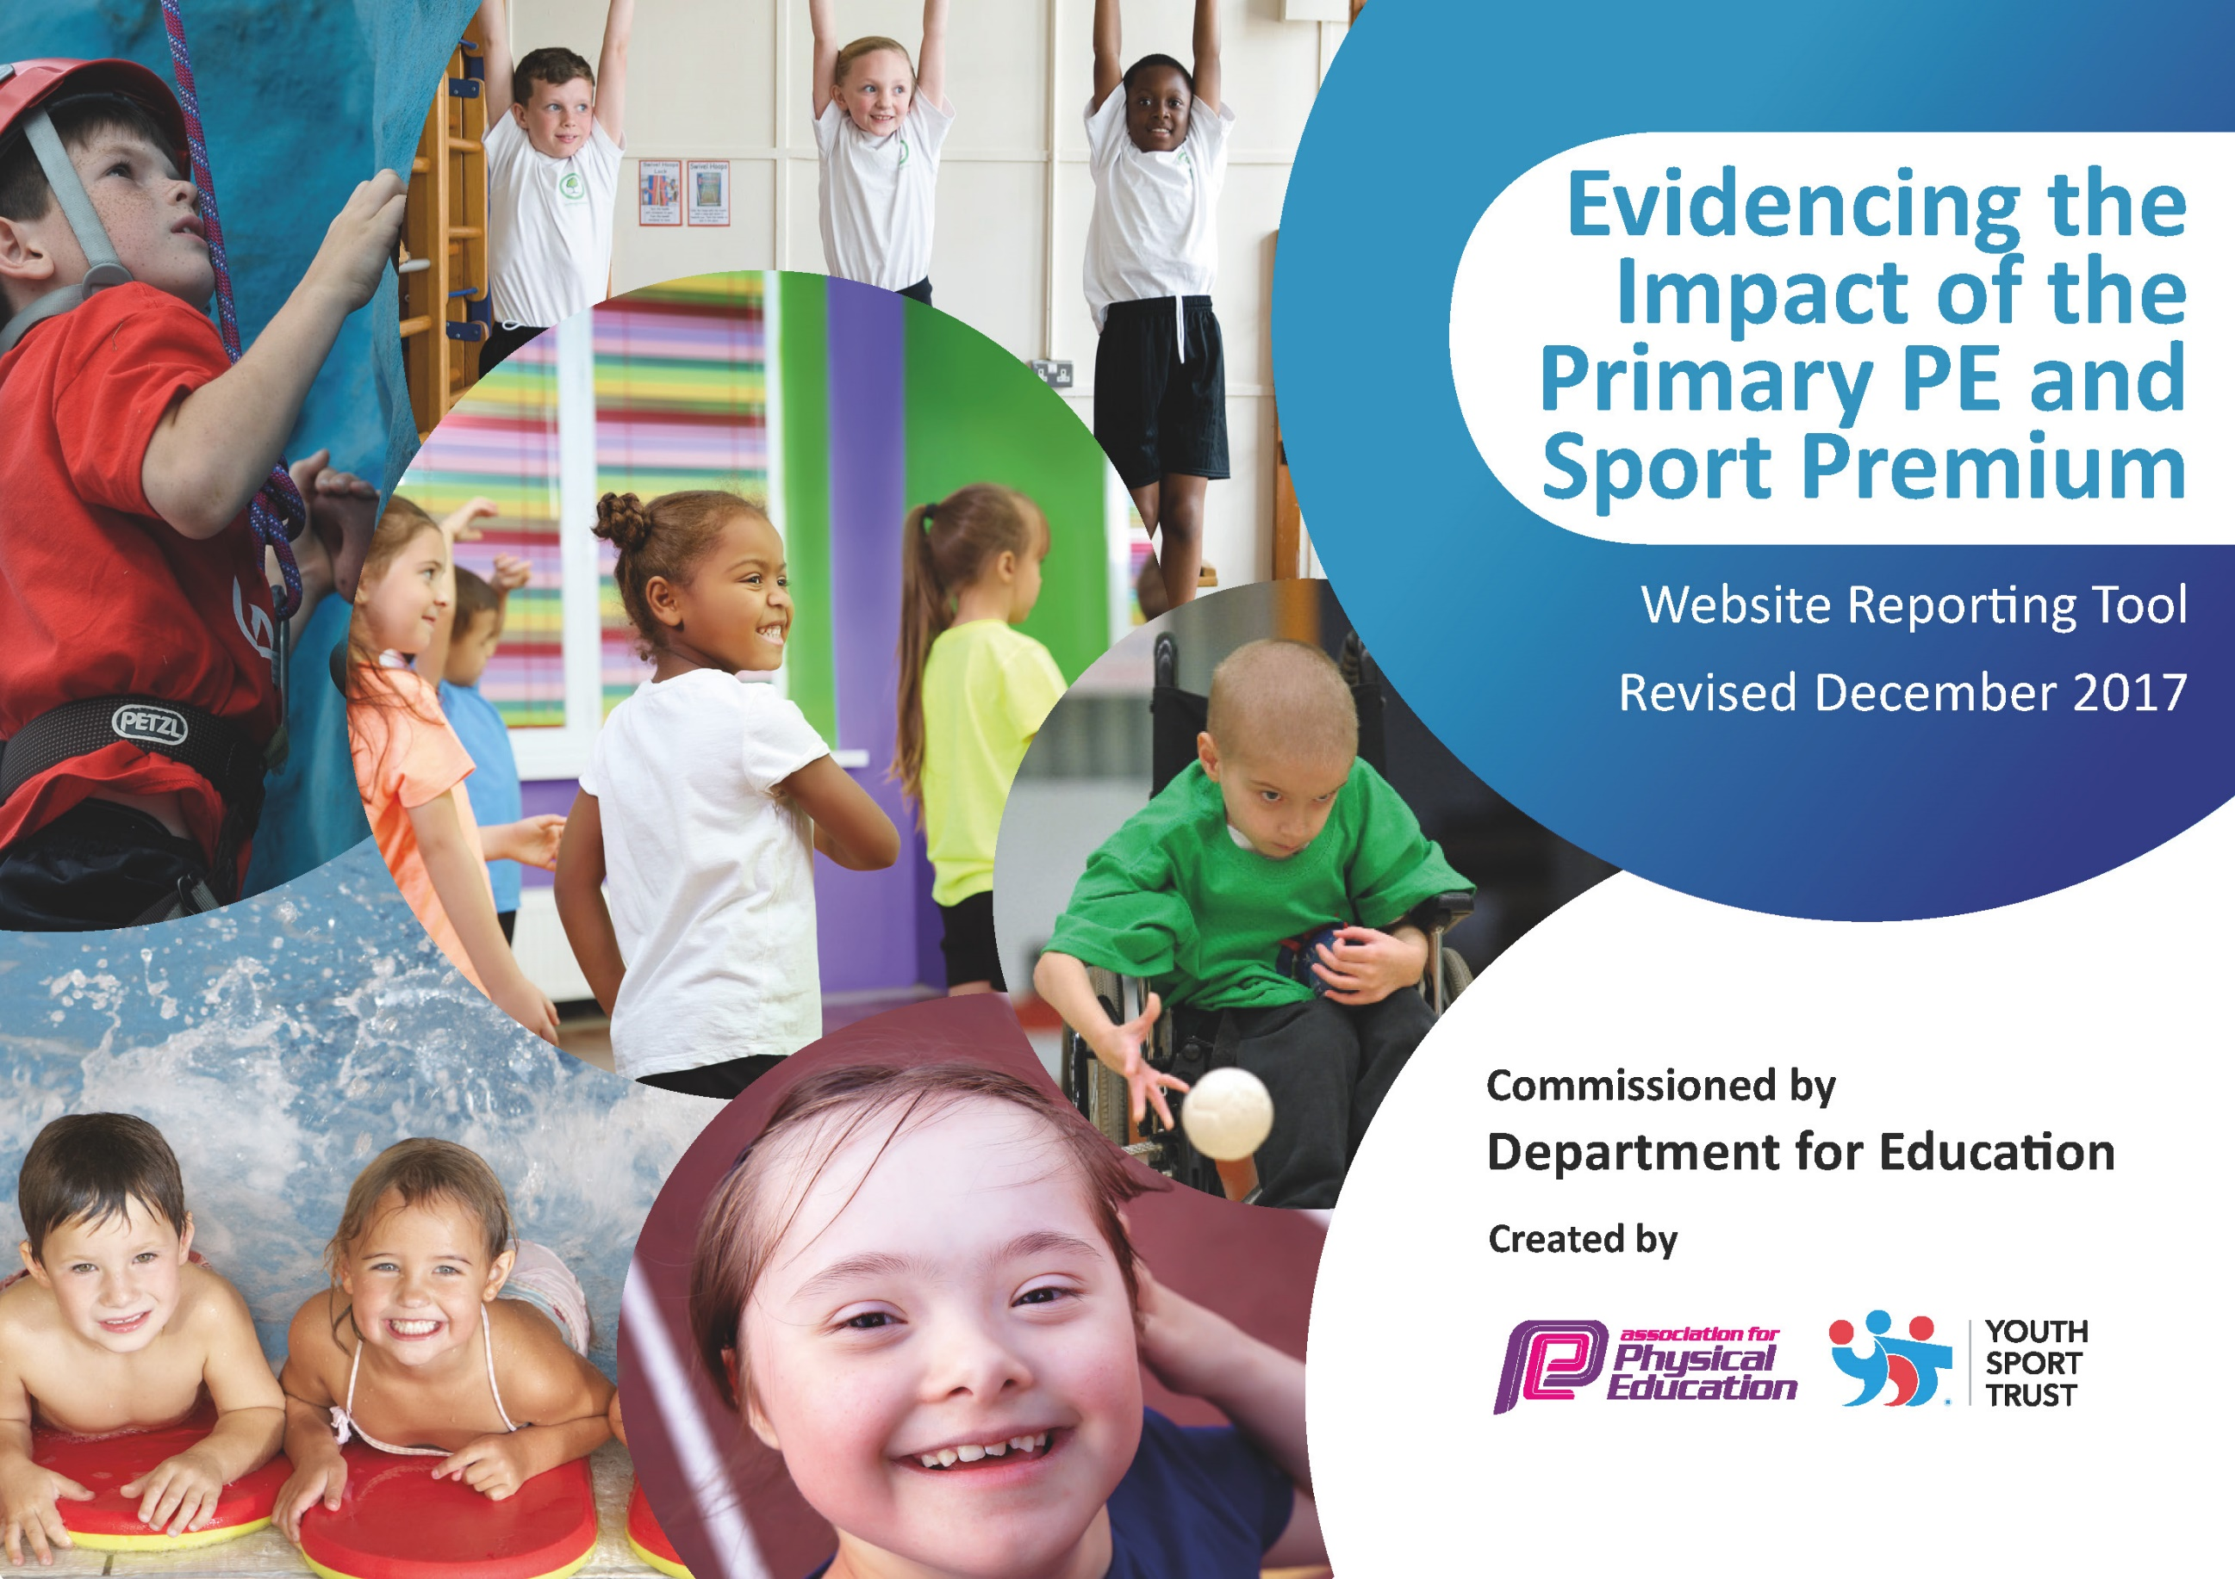

Schools must use the funding to make **additional and sustainable** improvements to the quality of PE and sport they offer. This means that you should use the Primary PE and Sport Premium to:

* develop or add to the PE and sport activities that your school already offers
* 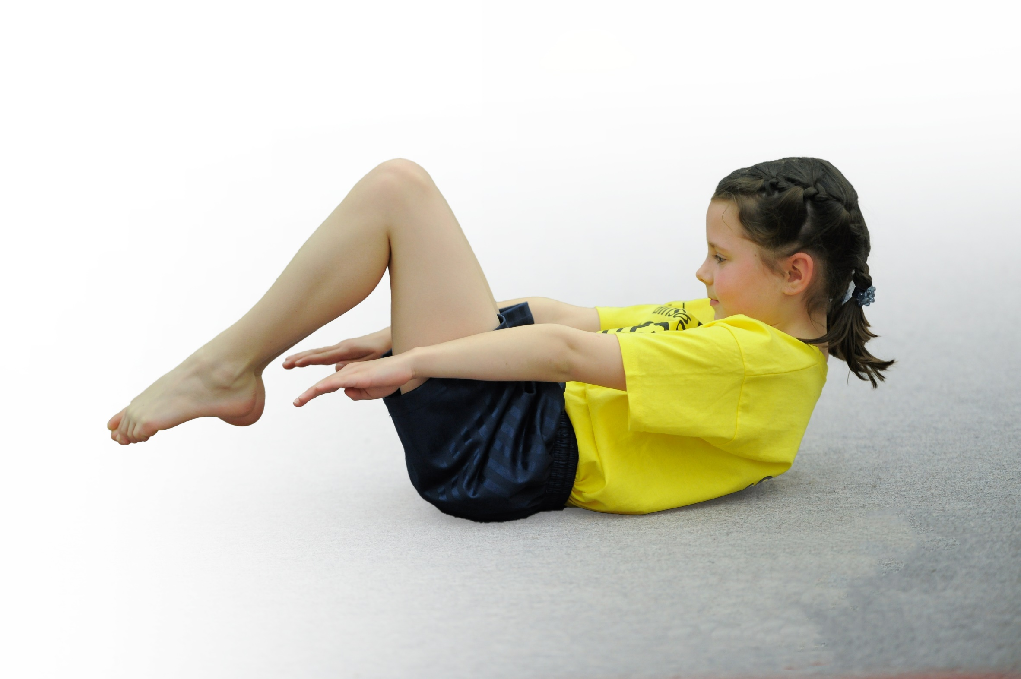build capacity and capability within the school to ensure that improvements made now will benefit pupils joining the school in future years

Please visit [gov.uk](https://www.gov.uk/guidance/pe-and-sport-premium-for-primary-schools) for the revised DfE guidance including the 5 key indicators across which schools should demonstrate an improvement. This document will help you to review your provision and to report your spend. DfE encourages schools to use this template as an effective way of meeting the reporting requirements of the Primary PE and Sport Premium.

We recommend you start by reflecting on the impact of current provision and reviewing the previous spend.

Under the [Ofsted Schools Inspection Framework](https://www.gov.uk/government/publications/school-inspection-handbook-from-september-2015), inspectors will assess how effectively leaders use

the Primary PE and Sport Premium and measure its impact on outcomes for pupils, and how effectively [governors](https://www.gov.uk/government/publications/governance-handbook) hold them to account

for this.

Schools are required to [publish details](https://www.gov.uk/guidance/what-maintained-schools-must-publish-online#pe-and-sport-premium-for-primary-schools) of how they spend this funding as well as on the impact it has on pupils’ PE

and sport participation and attainment.

We recommend regularly updating the table and

publishing it on your website as evidence

of your ongoing review into how you are using the money

to secure maximum, sustainable impact. To see an example of how to complete the table please click [HERE](http://www.afpe.org.uk/physical-education/wp-content/uploads/Template-Exemplification.pdf).

Support for review and reflection - considering the 5 key indicators from DfE, what development needs are a priority for your setting and your students now and why? Use the space below to reflect on previous spend, identify current need and priorities for the future.

|  |  |
| --- | --- |
| Key achievements to date: | Areas for further improvement and baseline evidence of need: |
| Pupils accessing high quality gymnastic teaching through expert coaching and staff being upskilled through observing and mentoring  Pay a TA to lead areas of sport throughout the school  Continue to provide opportunities and facilities for our children  Co-ordinate gifted and talented opportunities through intersport competitions and tournaments  Outdoor learning- Lesson House orienteering  To introduce the Golden Mile  Purchase Junior multi use goal, rebound walls and basketball hoop for grassy area  The whole school swims at least once a week and in KS2, three times a week in our school pool. | Staff are now more skilled and confident to teach gymnastics. Staff are more involve in holding and supporting the children in the appropriate way.  Children receive high quality teaching and as a result are achieving a higher standard in their lessons back at school, such as headstands, cartwheels, beam work.  The level of teaching in lessons observed back at school has increased to at least good and some are outstanding.  More opportunities for our pupils to participate in sporting activities after school, developing skills and teamwork  Our children develop skills in competitive sport and strive for excellence  Our children show confidence and growing skill in using maps and compasses in unfamiliar surroundings. They are able to demonstrate their skills back in school  Our children are encouraged to improve their fitness levels and recognize the importance of daily exercise/acknowledge the positive impact on their health  Our pupils have access daily to sports equipment where they can develop and hone skills taught in lessons  All of our children have access to learn to swim. This is an additional provision for our KS1 and Year 3-4 pupils as swimming is not compulsory. We recognize that the pool is not large/deep enough for our Y5/6 children to demonstrate the key skills well and so have looked at taking them swimming at a local pool. |

|  |  |
| --- | --- |
| Meeting national curriculum requirements for swimming and water safety | Please complete all of the below*: |
| What percentage of your current Year 6 cohort swim competently, confidently and proficiently over a distance of at least 25 metres? | 76% |
| What percentage of your current Year 6 cohort use a range of strokes effectively [for example, front crawl, backstroke and breaststroke]? | 76% |
| What percentage of your current Year 6 cohort perform safe self-rescue in different water-based situations? | 29% |
| Schools can choose to use the Primary PE and Sport Premium to provide additional provision for swimming but this must be for activity **over and above** the national curriculum requirements. Have you used it in this way? | Yes |
|  | |

*Schools may wish to provide this information in April, just before the publication deadline.

**Action Plan and Budget Tracking**

Capture your intended annual spend against the 5 key indicators. Clarify the success criteria and evidence of impact that you intend to measure to evaluate for students today and for the future.

|  |  |  |  |  |
| --- | --- | --- | --- | --- |
| **Academic Year:** 2017/18 | **Total fund allocated:** | **Date Updated: February 2018** | |  |
| **Key indicator 1:** The engagement of all pupils in regular physical activity – Chief Medical Officer guidelines recommend that primary school children undertake at least 30 minutes of physical activity a day in school | | | | Percentage of total allocation: |
| 45% |
| School focus with clarity on intended **impact on pupils**: | Actions to achieve: | Funding allocated: | Evidence and impact: | Sustainability and suggested next steps: |
| To continue the Golden Mile across the school with all pupils. Ensuring all pupils undertake at least 15 minutes of additional activity per day.  To employ a sports apprentice to begin to lead areas of sport throughout the school. To help with the provision of opportunities for competitive sport as well as engaging the less active at playtimes etc.    Outdoor Learning  Active Travel Active Learning | Ensure each class has Golden Mile Monitors to input data.  Identify several new courses for a daily mile.  Timetable Baseline assessments with Premier Sport.  Sept March July  To support and engage the least active children through running small lunch clubs for practicing skills.  Attend PLT meetings with TA to continue links with the partnership and promote new sporting opportunities back in school.  To help maintain the competitive sporting opportunities against other schools as well as arranging intra house competition.  Sports apprentice will need supporting and teaching. PE lead or PE TA will need to be released to have time to do this.  To improve our outdoor learning provision in KS1 and roll out to KS2 as well.  Make teachers aware of the government’s new active travel and active learning initiatives through staff meetings.  PE lead to be given time to plan for this. Teachers to visit other schools to see active learning in practice.  A TA, teacher or Parent to begin training in outdoor learning. | £475  £6,195  £1000 | ALL pupils involved in at least 15 minutes of additional activity every day.  Overall health and fitness will improve and be shown in the Baseline and progress results as well as in PE lessons.  Subjective measure of engagement monitored by staff leading PE lessons.  Inter/intra sport will be effectively coordinated. Calendar of events to be updated.  Pathways mapped- local. Area and then county level.  Photographs of lunchtime activities to be recorded over time to show increased numbers of children being active. Pupil voice will capture attitudes towards being active.  More children taking part in competitions whether inter or intra.  Class teachers will record the number of opportunities for each child to experience active learning.  Photographs of outdoor learning opportunities to be recorded over time to show increased numbers of children being active. Pupil voice will capture attitudes towards being active. | Ensure Year 6 train the Year 5 in the summer term as Golden Mile monitors. Move towards the daily mile which is free. Video Baseline assessment to follow for next year.  Sports Apprentice to work with sport monitors in school to pass on skills for organizing and setting up intra sport so this can continue every year.  Once an adult is trained or has visited other schools for ideas- outdoor learning will be sustainable.  Resource packs to be made up to continue provision for the following year. |
| **Key indicator 2:** The profile of PE and sport being raised across the school as a tool for whole school improvement | | | | Percentage of total allocation: |
| 1% |
| School focus with clarity on intended **impact on pupils**: | Actions to achieve: | Funding allocated: | Evidence and impact: | Sustainability and suggested next steps: |
| Sport to be celebrated in assemblies every week to ensure the whole school is aware of the importance of PE and Sport and to encourage all pupils to inspire to being involved in the assemblies.  Notice boards in hall to raise profile of PE and sport for visitors and parents to see. Raise the profile of sport on Facebook and the website.  Sports Apprentice to increase profile by giving additional support in class, as well as to PE lead. | Achievements celebrated in assembly (match results and notable achievements in lessons etc.)  As well as introduction of any new initiatives, clubs etc.  Increased numbers of children to be praised for participation in sport and fitness. | £200 | Photographs of lunchtime activities to be recorded over time to show increased numbers of children being active.  Team lists and registers will record numbers of children involved in competition – whether intra or inter.  Noticeboards are full of information about matches/clubs/results and pupils are keen to attend. | SLT and governors will see the benefits of the raised profile and hopefully will commit to funding these areas if the funding is stopped.  Kate to present to the governors. |

|  |  |  |  |  |
| --- | --- | --- | --- | --- |
| **Key indicator 3:** Increased confidence, knowledge and skills of all staff in teaching PE and sport | | | | Percentage of total allocation: |
| 14% |
| School focus with clarity on intended  **impact on pupils**: | Actions to achieve: | Funding  allocated: | Evidence and impact: | Sustainability and suggested  next steps: |
| Upskilling of staff in gymnastics in order to deliver gymnastics back in school in the spring term. Purchase of equipment to assist with the deliverance of gymnastics back in school. | To use a percentage of sports funding to raise standards further in gymnastics. To enable all children to be constantly improving in all gymnastics lessons in school and achieve their potential.  To upskill staff in the teaching of gymnastics. | £2393 | List of CPD opportunities provided to increase subject knowledge for both TAs and staff.  Teachers more confident in the delivering of PE and pupils more enthused and engaged. | Whilst the funding continues we will ensure sustainability by recording sessions particularly of holds and technical skills. To create a resource rather like ‘Head over heels about Gymnastics’ by Gemma Coles |
| **Key indicator 4:** Broader experience of a range of sports and activities offered to all pupils | | | | Percentage of total allocation: |
| 8% |
| School focus with clarity on intended  **impact on pupils:** | Actions to achieve: | Funding  allocated: | Evidence and impact: | Sustainability and suggested  next steps: |
| Additional achievements:  Continue to offer a wider range of activities both within and outside the curriculum in order to get more pupils involved e.g. Bikeability  To continue to focus on those pupils who not take up additional PE and Sport opportunities.  Organise sailing activities for Year 6 pupils to develop knowledge and confidence in this area (linked to water safety)  Organise climbing session for Year 6 to develop their team work and climbing skills as well as core strength by delivering a climbing session | Participate in all local events which are offered thought the sports partnership and other organizations such as Sherborne Tennis Club.  Continue friendly fixtures against other schools on a fortnightly basis.  Arrange a pupil survey to ascertain what pupils would like.  Organise for a sailing day at Weymouth  Organise a day at Ready to Climb in Yeovil | £200.00  £512.50  £600 | Maintain good sporting opportunities at our school. Increase numbers participating in tournaments, matches etc  All Year 6 pupils participate in the sailing and enjoy the experience  Children develop key skills including confidence, physical dexterity, team work and collaboration and work on core and upper body strength | Staff will work together and share good practice all round. More staff therefore keen to get involved thus ensuring extracurricular activities continue but expand.  The school is not dependent on outside experts teaching PE and Sport.  Continue to hold this annually as an add on to their residential trip opportunities  Skills will be built upon at Barton Hall for the high climb and abseiling activities |
| **Key indicator 5:** Increased participation in competitive sport | | | | Percentage of total allocation: |
| 9% |
| School focus with clarity on intended  **impact on pupils**: | Actions to achieve: | Funding  allocated: | Evidence and impact: | Sustainability and suggested  next steps: |
| Sports Apprentice to introduce competitive sport through intra house competitions.  Engage more pupils in inter -sport competition by varying the sport and increasing number of teams taken | Range of intra sport competitions at lunchtimes.  Teaching Assistant paid to deliver football and netball after school | £500 | Numbers participating to increase over the year. Registers for the range of lunchtime activities to record activity levels across the year.  Record numbers involved in sport at the start of the year and at the end. | Train year 6 pupils who then train Year 5 pupils.  Monitors can then set up the teams, prepare equipment, create a table of points and fixture lust. |
| Other Indicators Identified by school |  |  |  |  |
| Additional Swimming: To ensure all existing swimmers increase their attainment thus increasing confidence in water.  All remaining non-swimmers to achieve 25 m thus meeting the statutory requirements.  All pupils can perform side self rescue over a varied distance so they are confident and safe in water. | Take Year5/6 to the local swimming pool rather than our school pool. 6 week block.  To utilize the swim teachers at the swimming pool to work alongside teachers to upskill them | £982.50 | Survey of current swimming ability already undertake. | Governors and parents to recognize the benefits of swimming in a full size pool in order to meet government requirements.  Teacher to work closely with the swim teachers to ensure more staff members are confident and competent in swimming. |