St Mary’s CE Primary School Operating plan – September 2020

“There cannot be a one size fits all approach. School leaders will be best placed to understand the needs of their school and communities and to make informed judgements about how to balance delivering a broad and balanced curriculum with the measures needed to manage risk. The system of controls provides a set of principles to help them do this and, if schools follow this advice, they will effectively minimise risk.” Guidance for full opening of schools July 2020 DFE
Schools must comply with Health and Safety law which require them to assess risks and put in place proportionate control measures. We have thoroughly reviewed our existing risk assessment and drawn up plans for the autumn term that address the risks identified using the system of controls below. Essential measures include:
- Requirement that people who are ill stay at home
- Robust hand and respiratory hygiene
- Enhanced cleaning arrangements
- Active engagement with the NHS Test and Trace
- Formal consideration of how to reduce contacts and maximise distancing between those in school wherever possible and minimise potential for contamination so far as is reasonably practicable
How contacts are reduced will depend on the school’s circumstances and will (as much as possible) include:
- Grouping children together
- Avoiding contact between groups
- Arranging classrooms with forward facing desks
- Staff maintaining distance from pupils and other staff as much as possible
Employers must protect people from harm, and this includes taking reasonable steps to protect staff, pupils and others from Corona Virus (COVID19) within the education setting. Risk cannot be entirely eliminated but steps can be taken to reduce it.

Opening
- All current pupils will be back in September full time from 7th September. This is mandatory for pupils of compulsory school age. Our new Reception pupils will attend school for five half days and will be full time in the second week
- In order to avoid having a staggered start and end to the day, which we recognise is not helpful to families, we will maintain our one-way system* to reduce congestion and bottlenecks and keep the flow of pedestrian traffic moving in the same direction. This has been well received by parents and children who have been in school during the summer. Please use the one-way system at all times during school pick up and drop off. If this does not work when the whole school is back, we may need to reconsider staggered starts and finishes
- Government advice is that parents should not gather at the school gates so it will be important to consider arrival time at school. Please be mindful of pre -school parents waiting, and give them space
- Parents will not be allowed in buildings as now unless invited, in order that school can be manage meetings appropriately and safely. Messages from parents can be passed through Google classroom for Y6 children or at the door for YR 1,2,3,4,5 or emailed/phoned through to the office for all. This has worked well during the last two months and there have been no issues with communication
- The gate will open at 8.45am and no one should be on site before that time please unless they are accessing Breakfast Club and 3.05pm for pick up
One way system* (Same as June/July 2020) – to be read in conjunction with diagram
Key Stage 1
Key Stage 1 children (Miss Langdon’s class and Miss Stuckey/Mrs Newton’s class) and parents walk from village hall side gate to EYFS playground and then follow path back around across the front of the main building and back up to the top playground and out. Over the summer, a concrete path will be laid for health and safety purposes.
PLEASE DO NOT WALK ACROSS THE GRASS AS IT TRANSFERS MUD ONTO PATHS WHICH CAN CAUSE SLIPS. If other people are collecting your child, please ensure they know this. Please DO NOT use the gate by the office to enter and exit - this is not for general use during the school run.
Key Stage 2
Morning drop off – Mr Simpson’s and Mrs Morton’s children walk from village hall side gate and then follow path to top playground and in through the brown door - parents to leave via top playground gate.
Afternoon pick up – Mr Simpson’s parents to follow one-way system, go up the steps to the vegetable garden, and wait in the vegetable garden or wait on the gravelled area (the gravelled area will become clear in September!) leaving the steps clear for access. Mrs Morton’s parents to wait in the top playground.
Drop off and collection Y6- Mrs Middleton’s children and parents walk from village hall side gate and follow the path around to the Year 6 classroom; parents to leave via top playground. Parents to wait on top playground to collect. If year 6 are able to meet parents off site/walk home (with written confirmation) that will help.
Please could all school users leave the top playground promptly at the beginning and end of the day
Gates will be closed at 9.15am. If parents and children arrive after this time, they will need to report to the office.
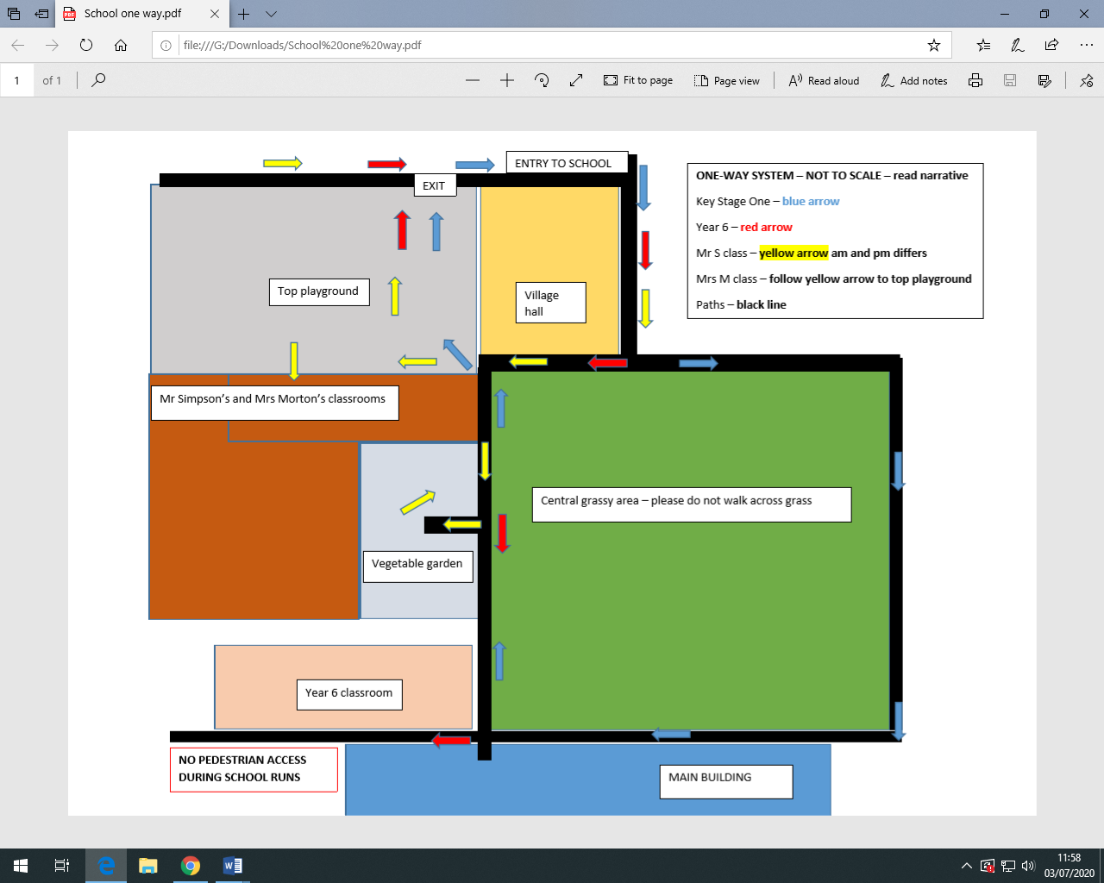
Classroom organisation
We have been requested to minimise the number of contacts a pupil has during the school day:
- Five classes will operate in bubbles of less than 30 children and children will stay in these bubbles all day. Our class sizes range from 17 to 25 currently
- The need to maintain the bubbles is important as if a child is found to be positive with Covid 19 it is less likely to affect the whole school community; it is quicker and easier to identify those pupils and staff that need to self-isolate. Our primary concern is safety but also to keep the school open
- Teachers and Teaching Assistants are allowed to teach in other classes with the use of additional precautions such as handwashing and keeping a reasonable distance from pupils to allow the smooth operating of the school and to facilitate the delivery of the school timetable. Where staff are working across bubbles, they should try to keep their distance as much as practicable, particularly if staff are working on a 1:1 or in small groups. The approaches of separating groups and maintaining distance are not ‘all or nothing’ options and will still bring benefits even if partially implemented. Time spent within 1m of a child should be minimised as should close face to face contact
- Supply teachers are allowed to be used
- It is acceptable for children NOT to distance within their group as it is recognised that younger children find this very difficult and it is not conducive to the way learning takes place, particularly in Early Years and Key Stage 1. Where staff or children cannot maintain distancing, particularly with younger children in primary schools, the risk is reduced by maintaining the bubbles or having forward facing desks
- Where practical and possible, children will face the front of the classroom to reduce close face to face contact
- A full curriculum will be offered as normal. There will be a period of assessment when teaching staff will judge the standard at which the children are working and where the gaps are. Additional tuition will then be allocated to help the children catch up – this is a professional decision made by teaching staff. This may be before or after school or during the day and run by school staff
- Pupils and teachers can take books home, although unnecessary sharing should be avoided if it does not directly relate to the education of the children
Breakfast club
- Will run but socially distanced so as not to compromise the class bubbles.
- Children will be seated in their bubbles and will not share resources
- Breakfast club will start at 8am as normal and children need to be in class at 8.45am to avoid walking against the flow of pedestrian traffic
- Parents will be expected to use the one-way system to drop off
Assemblies
- The Government have advised no whole school assemblies as this compromises the bubbles
- Head teacher and other staff members to broadcast whole school assemblies via TEAMs to classes
- Class assemblies can be carried out in bubbles

Lunch
- Lunch will be eaten in classrooms. We do not have the staffing capacity or time to provide hot lunches at this time. The health and safety of staff and children is compromised by carrying hot food around the school
- Packed lunches will be offered up until October term and will be reviewed in line with any new guidance
- Key Stage 2 playtimes will be staggered or zoned to avoid bubbles using the same space
Clubs
- There will be no after school or lunchtime clubs run at least for the first half term. This will be reviewed regularly but we have been directed to find ways to avoid mixing the bubbles – clubs are one area where children do mix from across the school
- There will be no inter school fixtures as yet
Uniform and personal items
- Children will wear the school uniform as normal: summer uniform up until October half term if the weather is warm and then winter uniform from October onwards. Reception children are not requested to wear summer uniform unless they have some pre-owned items
- School bags/lunch boxes and book bags are allowed. However, we have been asked to limit unnecessary personal items, such as toys etc. School will provide pencil cases for Key Stage two pupils. Water bottles should be named please
Attendance
- School attendance is mandatory from September and the usual rules of parents’ duty to ensure their child attends regularly at school where the child is a registered pupil and they are of compulsory school age apply
- School with work with any children who are showing signs of anxiety through the usual channels
- Holidays will not be authorised as usual. If families choose to travel abroad in term time, the quarantine period of 14 days may apply (Government guidelines dependant) – please be advised that penalty fines may be applied in this scenario for holidays booked after lockdown rules eased
Trips
- The Government is advising against overnight domestic trips currently
- Day trips may take place if the risk assessment can be satisfied including transport but must be in class bubbles
Volunteers
- Volunteers may be used to support the work of the school but they must be given appropriate roles and the mixing of volunteers across groups should be kept to a minimum
- Volunteers should remain 2m from staff and pupils where possible
- School will not be inviting volunteers into school to start with but will review at half term
Google Classroom
- School will set up new Google Classroom pages for the whole school in September and anticipate it mainly being used for homework and communication
- This is important in case the school is locked down and we can quickly and efficiently continue to provide a remote education as before
Sports
- Preferably, class bubbles will have their own sets of equipment. Where this cannot be achieved, sports equipment should be cleaned between each use by individual groups or rotated on a 72 hour basis and contact sports avoided
- Outdoor sports should be prioritised, and the hall used where it is not, maximising distances and paying attention to hygiene and cleaning
Behaviour Policy
We will be reviewing our Behaviour Policy in line with Covid19 regulations and communicating these clearly to you in September. It is important that parents and children understand our expectations and parents support the school in the implementation of these.
Assessment
The government have reinstated all standardised testing for the year 2021 including Year 1 phonics screening check, Key Stage 1 tests and teacher assessment, Year 4 multiplication tables check and Key Stage 2 tests and teacher assessment.
Medicine
If children require medicine during the day i.e. antibiotics, teaching staff can give parents a copy of the medicines form at the door to fill in. Year 6 parents can email the office prior to arrival or ring and we will bring a form out to you. Staff in the bubbles will need to administer any medicine. As ever, this is a courtesy and not an obligation.
Use of shared spaces
Staffroom
- The use of staffrooms must be minimised so staggered use of the staffroom is essential
- Staff cannot meet altogether except in rooms where they can be 2m apart
- Meetings can take place in the hall after school
- Staggered lunches and breaks will ensure that KS1 staff and KS2 staff can have breaks with enough space
Library
- Library use should be carefully supervised and cleaned after use
- Class use should be timetabled
- Use hand gel before entering and handling books
- Staff should use scanner rather than pupils
Toilets
- Toilets can be used by different bubbles but staff will manage the numbers of children using the toilets at a time
- Every effort should be made that children from different bubbles are not using toilets at the same time, where reasonably practicable
- Toilets will be cleaned regularly by staff

Prevention of COVID 19
Cleaning
- All staff will still carry out regular cleaning of toilets, frequently touched areas and shared resources throughout the day and after school
- Headteacher will continue to clean communal areas regularly and after school
- Shared resources must be cleaned after school or rotated and quarantined for 72 hours
Hygiene
- Good hygiene must be taught and practised and reinforced at home and at school
- Regular handwashing will continue to take place on arrival to school, before break (if eating) after break, before lunch and after lunch, after toileting etc
- ‘Catch it, kill it bin it’ will be reinforced
Illness
- Minimise contacts with individuals who are unwell by ensuring that those who have Corona Virus symptoms or who have someone in their household who does, do not attend school
- If anyone (staff or pupil) becomes unwell at school with a new continuous cough, high temperature, loss of or change in smell or loss of or change in taste, they must be sent home immediately and advised to follow the ‘Stay at home: guidance for households with possible or confirmed coronavirus infection’ which sets out that they must isolate for at least 7 days and should arrange to have a test to see if they have Corona Virus. Other members of their household (including any siblings) should self-isolate for 14 days from when the symptomatic person first had symptoms. THIS IS NOT NEGOTIABLE
- Children with symptoms will be moved to the ELSA room and kept in isolation until parents can collect. Parents will be requested to collect immediately. Any supervising staff member in close proximity should wear full Personal Protective Equipment. A window should be opened for ventilation. The room should be thoroughly cleaned afterwards, and PPE disposed of correctly in line with Public Health Guidance
- If the test of a pupil or staff member is found to be positive, the whole class bubble will need to self-isolate for 14 days. Dorset Public Health, Dorset Local Authority and SAST will be notified. The Health Protection Team (HPT) will support the school through the process of managing confirmed cases and notifying the appropriate contacts
- If a child is suffering from an asthma cough or croup, for example, parents will be advised to seek a GP advice and produce a supporting letter or seek a Covid19 test if a letter cannot be produced before the pupil can attend school. School will not be able to distinguish between symptoms and it is better to be safe than sorry
- PLEASE NOT DOSE CHILDREN WITH TEMPERATURES UP WITH CALPOL AND SEND THEM INTO SCHOOL. As parents we have all done it, but we really must not mask any of the four symptoms and the children will tell us if they have been administered Calpol – please don’t be offended if you are telephoned for a discussion
- Please support the school with this – our primary concern is to keep everyone safe

Containment
If schools have two or more confirmed cases within 14 days or an overall rise in sickness absence with COVID19 symptoms is suspected, there may be an outbreak and we must continue to work with the Health Protection Team who will be able to advise if additional action is required. In some cases, HPT may recommend that a larger number of pupils self-isolate at home as a precautionary measure.
Staff, governors and parent representatives have been consulted on this operating plan.
All parents were sent this operating plan on 10th July 2020

Emma Grunnill
Head Teacher

