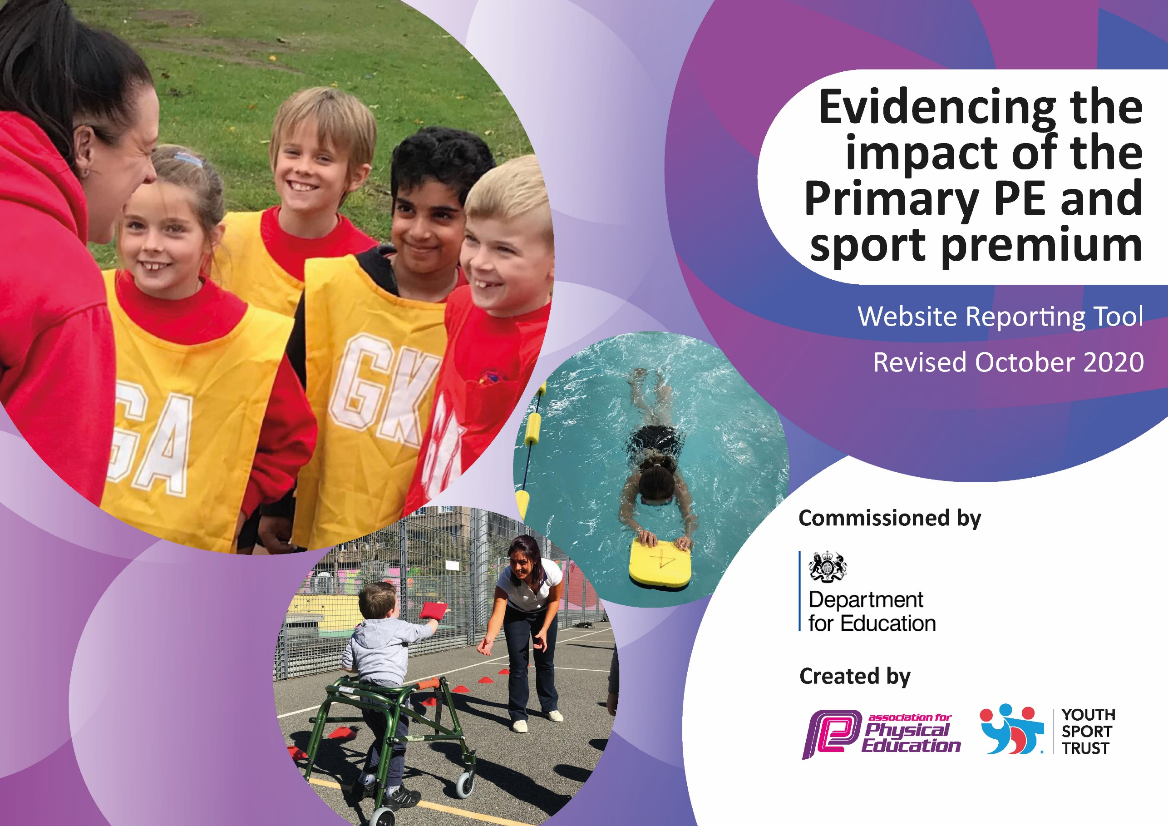
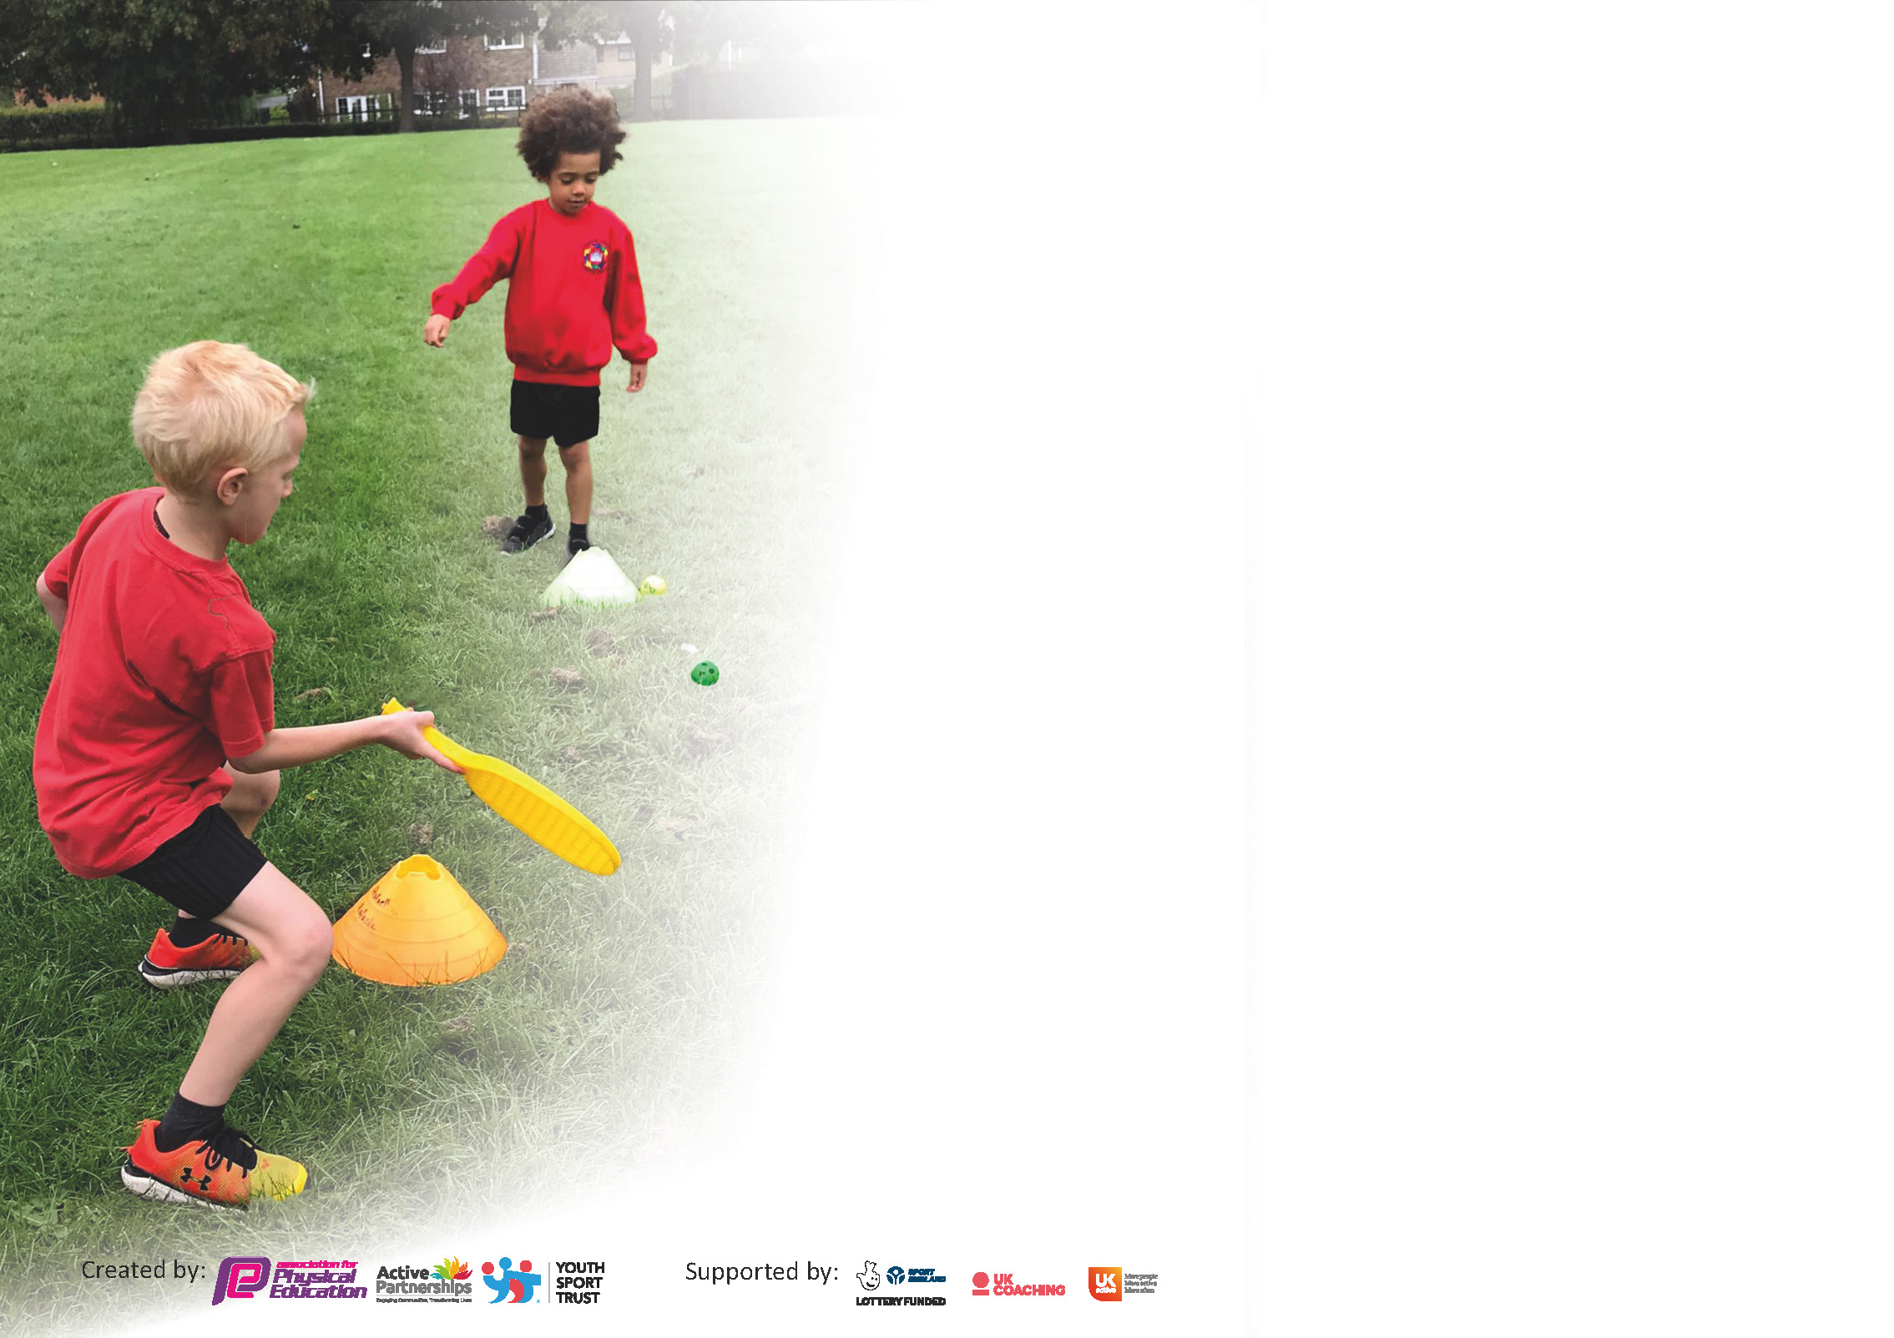

It is important that your grant is used effectively and based on school need. The Education Inspection Framework (Ofsted 2019 p64) makes clear there will be a focus on ‘whether leaders and those responsible for governors all understand their respective roles and perform these in a way that enhances the effectiveness of the school’.

Under the Quality of Education criteria (p41) inspectors consider the extent to which schools can articulate their curriculum (INTENT), construct their curriculum (IMPLEMENTATION) and demonstrate the outcomes which result (IMPACT).

To assist schools with common transferable language this template has been developed to utilise the same three headings which should make your plans easily transferable between working documents.

Schools must use the funding to make additional and sustainable improvements to the quality of Physical Education, School Sport and Physical Activity (PESSPA) they offer. This means that you should use
the Primary PE and sport premium to:

- Develop or add to the PESSPA activities that your school already offer
- Build capacity and capability within the school to ensure that improvements made now will benefit pupils joining the school in future years

Please visit gov.uk for the revised DfE guidance including the 5 key indicators across which schools should demonstrate an improvement. This document will help you to review your
provision and to report your spend. DfE encourages schools to use this template as an effective way of meeting the reporting requirements of the Primary PE and sport premium.

We recommend you start by reflecting on the impact of current provision and reviewing the previous spend.

Schools are required to publish details of how they spend this funding as well as on the impact it has on pupils’ PE and sport participation and attainment by the end of the summer term or by 31st July 2021 at the latest.

** In the case of any under-spend from 2019/20 which has been carried over this must be used and published by 31st March 2021.

We recommend regularly updating the table and publishing it on your website throughout the year. This evidences your ongoing self-evaluation of how you are using the funding to secure maximum, sustainable impact. Final copy must
be posted on your website by the end of the academic year and no later than the 31st July 2021. To see an example of how to complete the table please click HERE.
Created by: Supported by:

Please note: Although there has been considerable disruption in 2020 it is important that you publish details on your website of how you spend the funding - this is a legal requirement.
Support for review and reflection - considering the 5 key indicators from DfE, what development needs are a priority for your setting and your pupils now and why? Use the space below to reflect on previous spend and key achievements and areas for development.
N.B. In this section you should refer to any adjustments you might have made due to Covid-19 and how these will influence further improvement.
Key achievements to date until July 2020: | Areas for further improvement and baseline evidence of need:
• Silver School Games Mark held in 2019/20 for our commitment, engagement and delivery of competitive school sport.  • Sherborne Area Year 5/6 Netball champions, North Dorset Yr5/6 Netball Champions, Sherborne area Y6 Tag Rugby Runners Up, Yr3/4 YTFC  Runners Up Football Tournament, 1 child highest place cross country runner in Yeovil District, 2 children selected to run for North Dorset in County Cross Country Finals.  • Over 58% of children Y2 upwards have represented the school at festivals and tournaments.  • 62% of Year 6 children have represented the school in a sporting event against other schools this year. (Lockdown affected these results)  • 83% of children Y2 upwards attended an after-school club. (Lockdown affected results as school closed from March)  - All teachers Promoted active learning and PE opportunities throughout Lockdown -Google Classroom.  Every KS2 child for 6 weeks benefits from the facilities and teaching at Orchard Gymnastics in Yeovil. Pupils accessing high quality gymnastic teaching through expert coaching and staff being upskilled through observing and mentoring.  Sports Apprentice has lead areas of sport throughout the school- curriculum as well as extracurricular.  Links with the Community Established through the Yeovil Town Community Trust, many more footballing opportunities for our pupils. Links also with Yeovil and Sherborne Hockey Clubs as well as Chance to Shine Cricket community hubs. | How to provide quality, fitness enhancing PE lessons within the new COVID restrictions.  How to meet the needs of all pupils when PE needs to preferably take place outdoors-places limits on Dance and Gymnastics when COVID risks high.  Need to find further ways to increase activeness of pupils when in small bubble areas. Playground space is limited.  Provide 30 minutes of daily active learning through, Go Noodle, Wake and Shake, Golden Mile and other active programmes.  Ensure each bubble has enough PE/playground equipment for lessons and playtimes to reduce COVID risk.  Actively involve our pupils in the virtual festivals, competitions that are taking place in North Dorset.

Did you carry forward an underspend from 2019-20 academic year into the current academic year? YES/NO * Delete as applicable

If any funding from the academic year 2019/20 has been carried over you MUST complete the following section. Any carried over funding MUST be spent by 31 March 2021.
Academic Year: September 2020 to March 2021 | Total fund carried over: £5989 | Date Updated:
What Key indicator(s) are you going to focus on? KI1 ad KI3 |  |  |  | Total Carry Over Funding:
 |  |  |  | £5975
Intent | Implementation |  | Impact
Your school focus should be clear how you want to impact on your pupils.  High quality PE lessons to be taught in every bubble. (COVID-19 restrictions prevent sport apprentice and other well trained teachers teaching in every bubble. )  Provide opportunities for a daily 30 minutes of physical activity through the Golden Mile as well as creating more physical opportunities at playtimes. | Make sure your actions to achieve are linked to your intentions:  Sports apprentice to lead PE across the school and upskill staff  Use of IPADS to record lessons taught by sports apprentice and other more trained staff. These videos to be used by staff in other bubbles to enhance their own teaching.  Purchasing of more playground equipment such as skipping ropes, balls, stilts etc. Packs for each bubble to be put together.  Golden Mile Recording Package and Certificates- to engage and promote daily running.  Short Pathway needed to link the two routes to enable children to safely run throughout the winter. | Carry over funding allocated:  £2925 (Autumn term)  £1900  £500  £150.00  £500 | Evidence of impact: How can you measure the impact on your pupils; you may have focussed on the difference that PE, SS & PA have made to pupils re-engagement with school. What has changed?:  PE lessons restricted slightly-still 2 hours of PE a week but variety of sports reduced and mainly outdoor based.  Behaviour at playtimes to improve as children are active and are learning a to work together and problem solve.  Concentration in class better due to increase in physical activity  Sense of well being, improving ones own score and recognising the benefits of exercise and being outdoors. | Sustainability and suggested next steps and how does this link with the key indicators on which you are focussing this academic year?:

Meeting national curriculum requirements for swimming and water safety.  N.B Complete this section to your best ability. For example you might have practised safe self-rescue techniques on dry land. | This is difficult to say as Year 5 did not swim last year due to Lockdown.
What percentage of your current Year 6 cohort swim competently, confidently and proficiently over a distance of at least 25 metres?  N.B. Even though your pupils may swim in another year please report on their attainment on leaving primary school at the end of the summer term 2020. | %
What percentage of your current Year 6 cohort use a range of strokes effectively [for example, front crawl, backstroke and breaststroke]? | %
What percentage of your current Year 6 cohort perform safe self-rescue in different water-based situations? | %
Schools can choose to use the Primary PE and sport premium to provide additional provision for swimming but this must be for activity over and above the national curriculum requirements. Have you used it in this way? | Yes/No

Action Plan and Budget Tracking
Capture your intended annual spend against the 5 key indicators. Clarify the success criteria and evidence of impact that you intend to measure to evaluate for pupils today and for the future.

Academic Year: 2020/21 | Total fund allocated: £16980 | Date Updated: November 2020
Key indicator 1: The engagement of all pupils in regular physical activity – Chief Medical Officers guidelines recommend that primary school pupils undertake at least 30 minutes of physical activity a day in school |  |  |  | Percentage of total allocation:
 |  |  |  | 57%
Intent | Implementation |  | Impact
Your school focus should be clear what you want the pupils to know and be able to do and about  what they need to learn and to  consolidate through practice: | Make sure your actions to achieve are linked to your intentions: | Funding allocated: | Evidence of impact: what do pupils now know and what can they now do? What has changed?: | Sustainability and suggested next steps:
To continue the Golden Mile across the school with all pupils throughout the school year.  To enhance physical activity at playtimes through training of Playground leaders in each bubble as well as purchase of new equipment for each bubble.  To find new schemes that promote Physical Activity throughout the day both in and out of curriculum time. | Use of the Sports Crew and newly trained Playground Leaders to run and record  Playground leaders can run games, activities and be rewarded when seen engaging reluctant pupils. Equipment will provide inclusive opportunities and focus on a variety of skills not just ball skills.. | £100  £500 | Print out baseline and progress reports for each child to see increase in daily laps across the year. With a new all weather route achievement and fitness will go up and be maintained across the year.  Playground will be more active, happier and with less behaviour incidents. Health and fitness will improve and this will also be seen in PE lessons. Willingness of pupils to engage in lessons as they will have had time to practise skills learnt. | Sports Apprentice to ensure Sports Crew can pass on knowledge to next Leaders.
To continue to employ a sports apprentice to lead and support all areas of sport throughout the school.  To upskill current staff team | To support and engage the least active children through running small lunch clubs for practicing skills. To also focus on engaging those with behavioural issues.  Attend PLT meetings to continue links with the partnership and promote new sporting opportunities back in school.  To help maintain the competitive sporting opportunities against other schools and arranging intra house competition.  To teach and support in PE lessons to ensure all children participate to their fullest level/ability. To ensure progress is made in each lesson and a progression of skills followed.  To support a sports crew (made up of 2/3 children from each class) to promote sport and fitness to their peers. | £9000 (Spring and Summer terms) | Inter/intra sport will be effectively coordinated. Calendar of events to be updated. Sports Newsletter sent out.  Photographs of lunchtime activities to be recorded over time to show increased numbers of children being active. Displayed on sports board.  Floor books will show progression across year groups.  Photos of the crew on the sports board. Activities run and roles will be promoted on the board, school Facebook and website . | Sports Apprentice to work with sport crew in school to pass on skills for organizing and setting up intra sport so this can continue every year.  Floor books and development of QR codes will enable skills and lesson ideas to be passed on every year.  As the crew move up through the school and new members join, more children will be aware of how to run sporting events, equipment needed and how to lead warmups and cool downs.
Key indicator 2: The profile of PESSPA being raised across the school as a tool for whole school improvement |  |  |  | Percentage of total allocation:
 |  |  |  | 4%
Intent | Implementation |  | Impact
Your school focus should be clear what you want the pupils to know and be able to do and about  what they need to learn and to  consolidate through practice: | Make sure your actions to achieve are linked to your intentions: | Funding allocated: | Evidence of impact: what do pupils now know and what can they now do? What has changed?: | Sustainability and suggested next steps:
To work through the self review tools on the School Games Mark in recognition of our commitment to PE and sport. | Co-ordinator and apprentice to collate evidence and submit application. | Time needed  Supply £350 | Silver Mark maintained- Work towards Gold Mark once these awards reinstated after COVID 19 | To then maintain the Gold Mark for the following year.
PE lead to organise teachers to continue to record scores, tournament results and ensure they are on Facebook, Website etc.  All festivals, events, matches to be evidenced in the floor books. | Increased numbers of children to be praised for participation in sport and fitness.  A record of the school PE curriculum and opportunities for active learning in the Year group floor books.  A whole school floor book to celebrate participation as well as achievement in extracurricular sport. | Time needed  Supply cover  £350 | Website full of photos/videos of children’s achievements.  Photos stuck into floor books to record participation as well as progression across lessons and year groups.  PE lead will be able to see and monitor the delivery of PE lessons throughout the school as well as ensuring progression.
Continue promotion of Physical Activity at home through Google Classroom.  Encourage engagement at home by setting challenges or asking for photos of walks, bike rides etc | Physical Activity of children outside of school to be celebrated. Encourage others to try different activities or sports.  Time taken to celebrate in class and share photos.

Key indicator 3: Increased confidence, knowledge and skills of all staff in teaching PE and sport |  |  |  | Percentage of total allocation:
 |  |  |  | 0%
Intent | Implementation |  | Impact
Your school focus should be clear | Make sure your actions to | Funding | Evidence of impact: what do | Sustainability and suggested
what you want the pupils to know | achieve are linked to your | allocated: | pupils now know and what | next steps:
and be able to do and about | intentions: |  | can they now do? What has
what they need to learn and to |  |  | changed?:
consolidate through practice:
Recording of skills across the curriculum,  To benefit both teaching staff and pupils  (See also KI1) | Purchase of iPad to video technical holds and skills.  Use of QR codes to be cascaded to all staff so all floor books contain them. | (£10,900 shared with KI1) | Staff will be able to learn from outside agencies such as Orchard Gym. A video of the holds to use when teaching forward rolls can be viewed again and again.  Videos can be made of children’s forward rolls etc to help with giving feedback and improving technique. | Videos can be used year after year to remind teachers of technical holds.
Key indicator 4: Broader experience of a range of sports and activities offered to all pupils |  |  |  | Percentage of total allocation:
 |  |  |  | 39%
Intent | Implementation |  | Impact
Your school focus should be clear | Make sure your actions to | Funding | Evidence of impact: what do | Sustainability and suggested
what you want the pupils to know | achieve are linked to your | allocated: | pupils now know and what | next steps:
and be able to do and about | intentions: |  | can they now do? What has
what they need to learn and to |  |  | changed?:
consolidate through practice:
Additional achievements:  To improve inclusion sport opportunities particularly as pupils with mobility restrictions in KS2.  To provide a water based activity (sailing) for year 6 to build confidence and collaboration  To support the funding of an outdoor activity for year 6 (orienteering, abseiling, etc) at a local OEC to build confidence and team building  Outdoor Learning – Equipment to be purchased: shelters, spades, wheel barrows, for the wildlife area at the bottom of school field.  To support the funding and build of a new hard surface netball court  To fund additional swimming lessons for those pupils who cannot swim one length in Year 6 | Purchase two sets of Boccia  Enter Boccia virtual tournaments.  All children knew to this sport, Everyone sat so no issues for restricted mobility.  Quotes have been sought and the area has ben prepared circa £25000  Assess pupils’ ability and arrange additional lessons at local pool | £200  £100  £200  £5680  £500 | All children take part in act8ivity and report high levels of satisfaction and increased self confidence  The school lacks a facility to play netball and cannot host matches. This would make a massive difference to playtimes and PE within the school day and afterwards for extra curricular opportunities.  All children can swim one length before the end of Primary school | School needs to prepare a pre-app form with the LA for planning permission.  A hard surface would require very little in the way of upkeep. The PTA already has a sum of money withheld for the court

Key indicator 5: Increased participation in competitive sport |  |  |  | Percentage of total allocation:
 |  |  |  | 0%
Intent | Implementation |  | Impact
Your school focus should be clear | Make sure your actions to | Funding | Evidence of impact: what do | Sustainability and suggested
what you want the pupils to know | achieve are linked to your | allocated: | pupils now know and what | next steps:
and be able to do and about | intentions: |  | can they now do? What has
what they need to learn and to |  |  | changed?:
consolidate through practice:
To increase participation in virtual events during this COVID-19 period. | Important to continue our intra and inter sporting opportunities.  Teachers and Sport apprentice given time to prep these virtual events and coordinate across bubbles. |  | Children will experience a very different type of competition and will try different sports.  Focus will be team but mainly individual performance and determination.
Sporting Success 2019-20
Yr. 6 Tag Rugby Runners up
Yr5/6 Sherborne Area Winners Netball
YR5/6 North Dorset Netball Winners
Yr3/4 YTFC Runners Up Football Tournament
1 child highest place cross country runner in Yeovil District.
2 children selected to run for North Dorset in County Cross Country Finals.

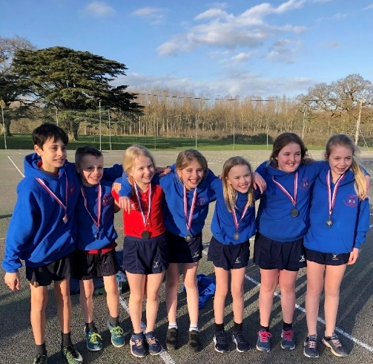

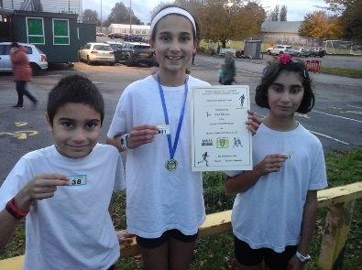
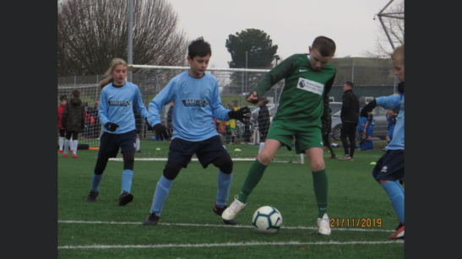

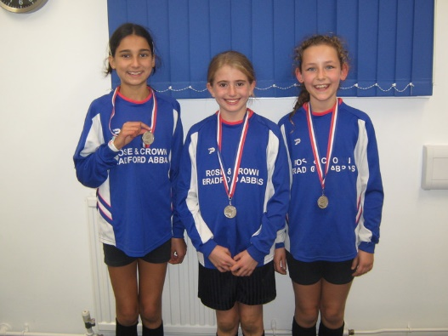

Signed off by
Head Teacher:
Date:
Subject Leader:
Date:
Governor:
Date:

