COVID-19 Outbreak Management Plan

This template is subject to change pending further National or Regional PHE guidance and review of the Contingency Framework for Education and Childcare settings.

School: St Mary’s Primary School

Plan Administration

Version number: | 1
Date of Issue: | September 2021
Electronic copies of this plan are available from SAST Central Office (Ami Jaruszek - Compliance and Administration Manager)
Date of next review: | When Govt guidance changes/an outbreak occurs or Dec 2021
Person responsible for review: | Emma GRUNNILL

Introduction

This plan is based on the DfE’s Contingency Framework which lays out how to manage local outbreaks of COVID-19. The guidance states schools should have “outbreak management plans”, outlining “how they would operate” if any of the measures described in the guidance were recommended for their setting or area.

The contingency framework (latest edition) states that councils, directors of public health and Public Health England health protection teams can recommend certain measures for individual schools or clusters of settings.

This may happen to help manage outbreaks in schools, or if there is an “extremely high prevalence” of COVID-19 in the community and other measures have failed to reduce transmission, or as part of a package of measures “responding to a variant of concern”.

If there is a need to address more widespread issues across an area, “ministers will take decisions on an area-by-area basis”.

Schools will need to consider the implementation of some, or all, of the measures in this plan in response to recommendations provided by their local Public Health team, Public Health England (PHE) health protection team, the DfE or the government.

Advice should be sought from Ami Jaruszek - Compliance and Administration Manager on Ami.Jaruszek@sast.org.uk when liaising with PHE or the DfE.

When should schools contact Ami?

It may be necessary to implement these measures in the following circumstances:

- To help manage a COVID-19 outbreak within the school
- If COVID-19 infection rates in the community are extremely high, and other measures have failed to reduce transmission
- As part of a package of measures responding to a ‘Variant of Concern’ (VoC)

Testing (Primaries only)
If recommended, Primary Schools will increase the use of home testing by staff.

Face Coverings (Primary only)
If recommended, staff and visitors who are not exempt from wearing a face covering:

- Will be asked to keep on or put on a face covering when arriving at school and moving around indoors in places where social distancing is difficult to maintain, such as in communal areas

and

- Will be asked to wear a face covering in classrooms or during activities, unless social distancing can be maintained, or a face covering would impact on the ability to take part in exercise or strenuous activity

Shielding
Schools will adhere to national guidance on the reintroduction of shielding, which would apply to those on the shielded patient list (SPL).

Schools will carry out a risk assessment and speak to individuals required to shield about additional protective measures in school or arrangements for home working or learning.

Other measures
If recommended, schools will limit:

- Residential educational visits
- Open days
- Transition or taster days
- Parents and volunteers coming into school
- Live performances

Once again, please seek advice from Ami Jaruszek - Compliance and Administration Manager on Ami.Jaruszek@sast.org.uk

Attendance restrictions
Attendance restrictions will only be recommended as a last resort.
As with other periods of restricted attendance, schools should provide “high quality remote education” for all pupils or those not attending. If attendance restrictions are required across an area, the government will publish “detailed operational guidance” for schools.

Restrictions on attendance may be advised by local teams for individual settings or clusters (no more than 3 or 4) of “closely linked settings”.

If recommended, schools will implement the measures in this section. If restrictions in special schools are needed, the DfE’s attendance expectations “will remain in line with the equivalent age groups in mainstream schools”.

Alternative provision “should continue to allow all children or pupils to attend full time”.

Eligibility to remain in school
In the first instance, schools will stay open for:

- Vulnerable pupils (LA identified)
- Vulnerable pupils (school identified)
- Children of critical workers (Govt definition)
- Reception, Year 1, Year 2 and Year 6 Pupils

If further restrictions are recommended, schools will stay open for:

- Vulnerable pupils
- Children of critical workers

Education and support for pupils at home
All other pupils will be required to stay at home and will receive high quality remote education.

Schools will aim to deliver remote education that meets the same quality and quantity of education that pupils would receive in school, as outlined in its remote learning policy and ensure a record is kept of learners accessing remote learning.

The school uses Google Classroom as its RL platform as well as TEAMS and Zoom for live teaching sessions.

The school will continue to prioritise meals or lunch parcels for pupils eligible for benefits-related free school meals while they are not attending school because of COVID-19 isolation guidelines.

School will make contact with parents to gauge need and meals should collected from the school Office at 11.45am.

Wraparound care
Schools will limit access to before and after-school activities and wraparound care during term time to those that need it most.

Schools will communicate who will be eligible to attend once the restrictions are confirmed.

Safeguarding
Schools will review their child protection policy to make sure it reflects the local restrictions and remains effective.

Schools will aim to have a trained DSL or deputy DSL on site wherever possible.

- If the DSL (or deputy) can’t be on site, they can be contacted remotely by phone 01935 476515 leaving a message which will accessed via email. DSL Emma Grunnill

On occasions where there is no DSL or deputy on site, a senior leader will take responsibility for coordinating safeguarding on site. It is the Headteacher’s responsibility to ensure there is always adequate qualified safeguarding staff available.

What we will do when a large number of students need to go home and isolate
Outline your plans for what you will do. This should include:

- Identifying pupils who require IT equipment and ensuring it is recieved
- Communicating swiftly with parents through our communication text system to collect pupils from school
- Uploading home learning onto Google Classroom quickly and emailing parents to ensure they can log in

Please ensure this COVID 19 Management Outbreak Plan is updated regularly and meets the DfE’s Contingency Framework.

Headteacher signature: Emma Grunnill

Date: 3rd September 2021

SAST receipt signed by Ami Jaruszek - Compliance and Administration Manager:

Date:

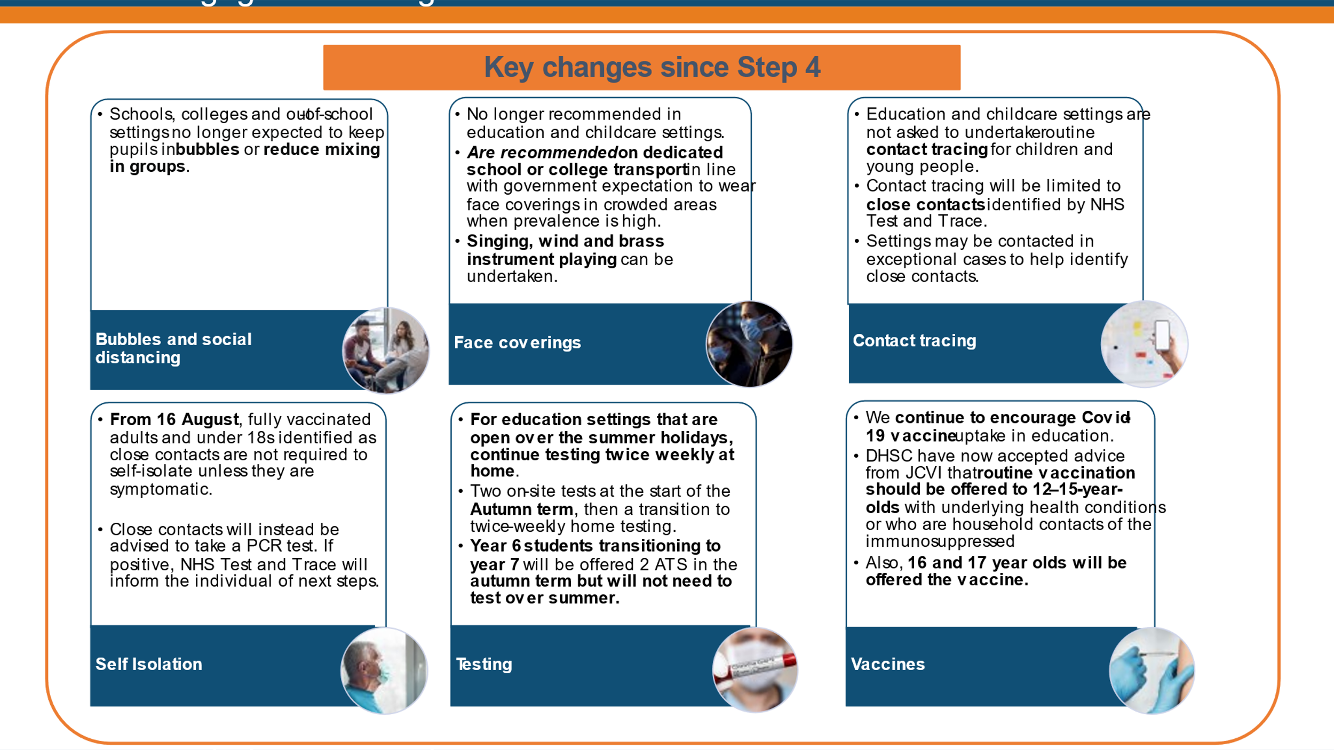
Information from the RSC local engagement – August 2021

