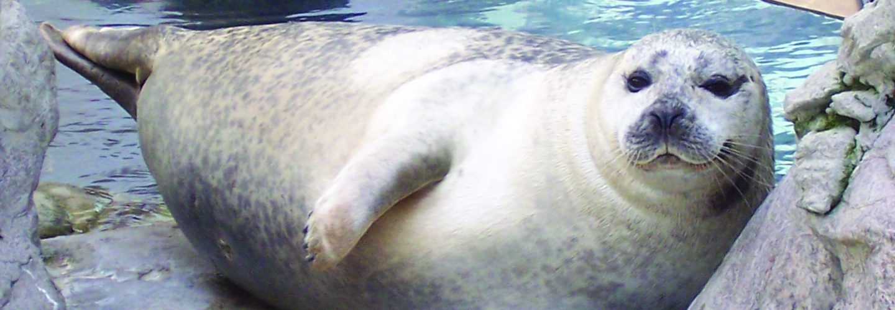

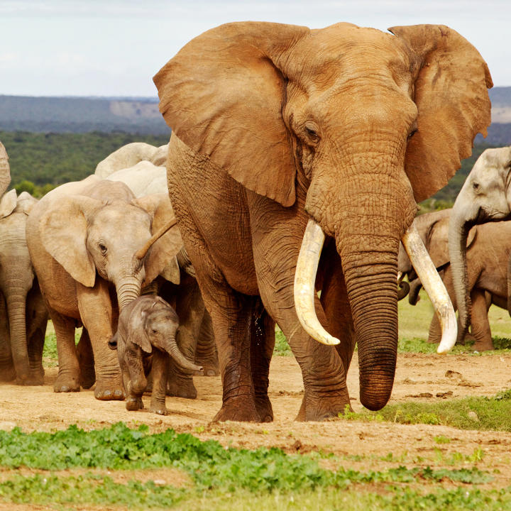
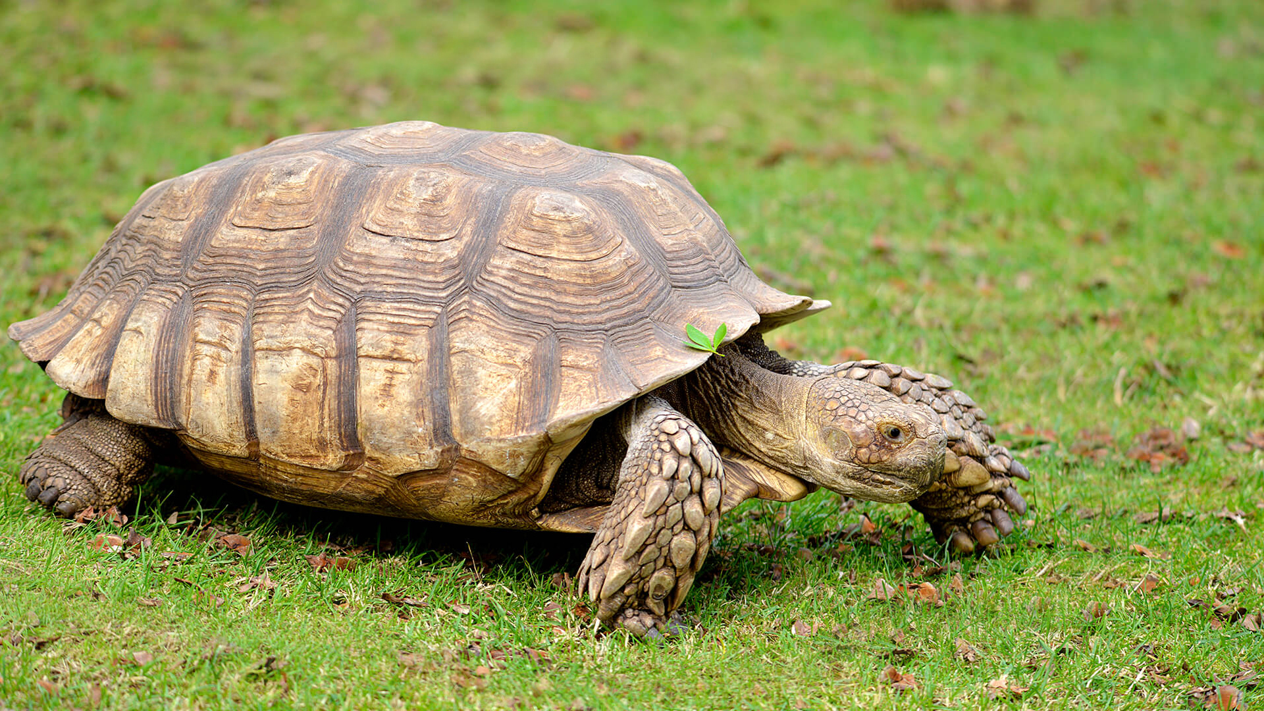

Amazing Animals
Spring Term
Churchwell
English
Segmenting sounds in words – Phase 3 and 5 sounds.
Sentence structure
Traditional Tales
Information Texts

The Gruffalo
The Gingerbread man
Room on the broom
We’re going on a bear hunt
Maths
Numbers to 100 – Year 1
Addition and subtraction
Division and sharing.
Time – o’clock and half past.
Fractions – whole, half, quarter of shape and quantity.
Position and direction including whole, half, quarter and three-quarter turns.
Place value
Science
Plants
Identify and name a variety of common wild and garden plants.
Classifying
Observations of changes
Features

Art/DT
Animals
Collages
Junk modelling
ICT
Coding
Beebots

Geography/History
Modern Explorers

Neil Armstrong, Christopher Columbus.

Similarities and differences between themselves and others, and among families, communities and traditions.

RE
Celebrations

PE
Gymnastics
Ball skills – football
Music
Music express – Rhythm and pulse.
Animals
PSHE & SEAL
To discuss right from wrong
Making hard decisions
Choosing a realistic goal

